**Experiment 1**

**AIM:** Identify different kinds of cables and connect two computers without any switch/with switch.

**THEORY:** Types of Cables in Computer Networks

1. Twisted Pair Cable
2. Coaxial Cable
3. Fiber Optic Cable
4. Crossover Cable
5. Straight-Through Cable
6. **Twisted Pair Cable**

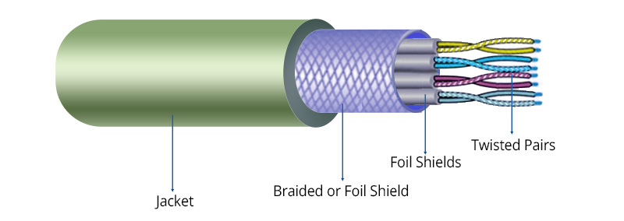

Twisted pair cables are the most commonly used cables in Ethernet networks. They consist of pairs of insulated copper wires twisted together to minimize electromagnetic interference and crosstalk. There are two main types: Unshielded Twisted Pair (UTP) and Shielded Twisted Pair (STP). UTP cables are widely used due to their cost-effectiveness and ease of installation, while STP cables have an extra shielding layer that provides better protection against interference, making them ideal for industrial and high-interference environments. Twisted pair cables are categorized based on their performance, with Cat5, Cat5e, Cat6, Cat6a, and Cat7 supporting different speeds and bandwidths.

**2. Coaxial Cable**

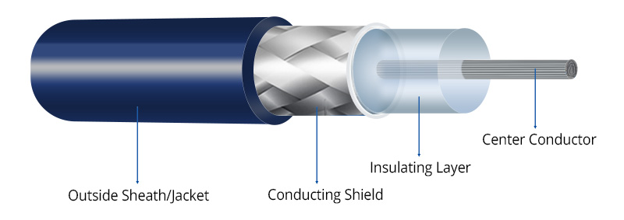

Coaxial cables were widely used in older computer networks and are still in use for cable television and broadband internet connections. They consist of a central copper conductor, an insulating layer, a metallic shield, and an outer insulating jacket. This design provides excellent resistance to electromagnetic interference, making coaxial cables suitable for transmitting data over longer distances compared to twisted pair cables. Older Ethernet networks, such as 10BASE2 (Thin Ethernet) and 10BASE5 (Thick Ethernet), relied on coaxial cables, but they have since been replaced by twisted pair and fiber optic technologies in modern networking.

1. **Fiber Optic Cable**

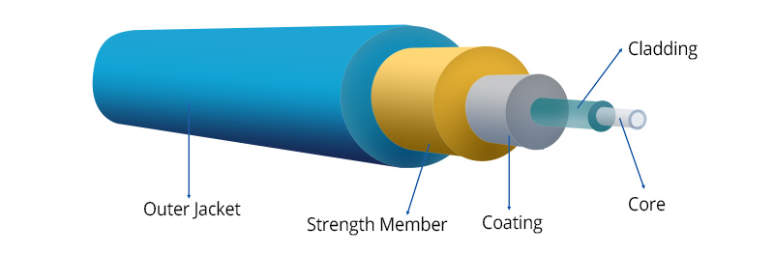

Fiber optic cables are used in high-speed and long-distance communication networks. Unlike copper-based cables, fiber optic cables use light signals to transmit data, providing much higher bandwidth and immunity to electromagnetic interference. They consist of a glass or plastic core surrounded by cladding and protective layers. There are two main types: Single-Mode Fiber (SMF) and Multi-Mode Fiber (MMF). Single-mode fiber is designed for long-distance communication, typically used in telecom networks and internet backbone connections. Multi-mode fiber, on the other hand, is suitable for shorter distances and is commonly used in LANs and data centers. Fiber optic cables are the preferred choice for high-speed internet, data centers, and enterprise networks.

**4. Crossover Cable**

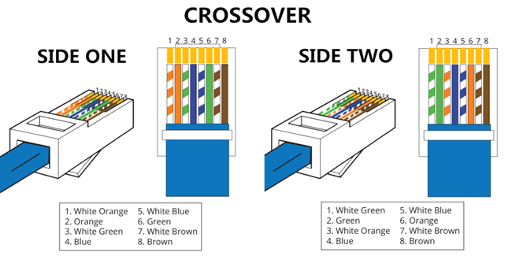

A crossover cable is a special type of twisted pair Ethernet cable that is used to connect two computers directly without a network switch or router. Unlike standard Ethernet cables, which have the same wiring pattern on both ends, crossover cables have specific wire pairs swapped to enable direct device-to-device communication. This was necessary in older networking environments where computers needed to share files without additional networking hardware. However, modern network interfaces often support Auto-MDI/MDIX, which automatically detects and configures the connection, reducing the need for crossover cables.

**5. Straight-Through Cable**

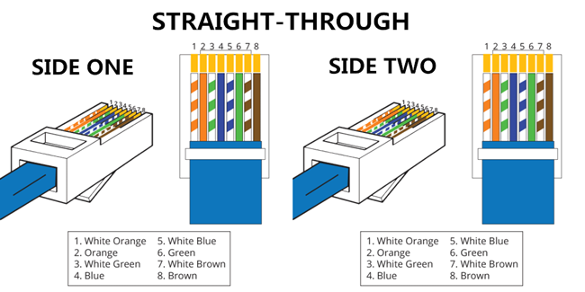

Straight-through cables are the standard type of Ethernet cables used to connect different networking devices, such as computers to switches, routers, or modems. These cables have the same wiring pattern on both ends and are used in most Ethernet-based LAN connections. They follow the TIA/EIA-568A or TIA/EIA-568B wiring standards, ensuring compatibility across various network devices. Straight-through cables are essential for establishing wired network connections in homes, offices, and data centers.

**Connecting Two Computers**

**1. Without a Switch (Direct Connection using a Crossover Cable)**

To connect two computers directly without a switch, a crossover Ethernet cable is used.

Steps for Direct Connection:

Connect the Crossover Cable: Plug one end into the Ethernet port of each computer.

Configure IP Settings: Since no DHCP server is available, manually assign static IP addresses:

Example: Computer 1 → 192.168.1.1, Computer 2 → 192.168.1.2

Subnet Mask: 255.255.255.0

Test the Connection: Open Command Prompt and use the ping command to check connectivity (ping 192.168.1.2 from Computer 1 and vice versa).

Enable File Sharing: Configure file-sharing settings to allow access between both computers.

**2. With a Switch (Using Straight-Through Cables)**

When using a network switch, standard straight-through Ethernet cables are used to connect both computers.

Steps for Connection via Switch:

Connect the Computers to the Switch: Plug straight-through Ethernet cables into the switch and connect them to each computer.

Configure IP Settings:

If a router with DHCP is present, it will automatically assign IP addresses. If DHCP is not available, set static IP addresses manually (as explained in the direct connection method).

Test the Connection: Use the ping command to verify connectivity.

Enable Network Sharing: Ensure file-sharing settings are enabled for seamless data transfer.